# Benthic monitoring summary: Pacific Remote Island Marine National Monument 2018

## About this summary

The purpose of this document is to provide a brief summary of the most recent survey efforts performed in the Pacific Remote Islands Areas in 2018 by the Ecosystem Sciences Division (ESD) of the NOAA Pacific Islands Fisheries Science Center as part of the Pacific Reef Assessment and Monitoring Program (Pacific RAMP). A more detailed assessment of the coral populations and reef community structure from the Pacific Remote Island Marine National Monument (PRIMNM) will be summarized in future publications.

## Sampling effort

* Ecological monitoring in the PRIMNM was performed from June 08 - August 11, 2018.
* Surveys were conducted at 108 sites across 5 islands: Jarvis, Palmyra, Kingman, Baker, and Howland.
* Coral demography, partial mortality, and condition were surveyed using belt transects; benthic community structure will be assessed from photoquadrat digital images.

Table 1. Reef zone (FRF = Forereef, BRF = Backreef, LAG = Lagoon, PRS = Protected Slope), area (hectare), and number of sites surveyed (n) for the three depth categories surveyed in the PRIMNM.

|  |  |  |  |  |  |  |  |
| --- | --- | --- | --- | --- | --- | --- | --- |
| Island | Zone | Shallow | nS | Mid | nM | Deep | nD |
| Baker | FRF | 211.62 | 4 | 118.63 | 4 | 60.02 | 2 |
| Howland | FRF | 113.86 | 3 | 40.21 | 4 | 18.79 | 2 |
| Jarvis | FRF | 155.15 | 9 | 191.11 | 13 | 19.64 | 5 |
| Kingman | FRF | 285.10 | 5 | 559.00 | 6 | 71.37 | 2 |
| Palmyra | FRF | 642.03 | 15 | 1527.37 | 15 | 623.95 | 7 |
| Kingman | BRF | 247.23 | 0 | 184.70 | 1 | 40.73 | 0 |
| Kingman | LAG | 0.60 | 0 | 76.05 | 4 | 1012.92 | 1 |
| Kingman | PRS | 0.00 | 0 | 1196.48 | 3 | 188.97 | 3 |

## Overview of data collected

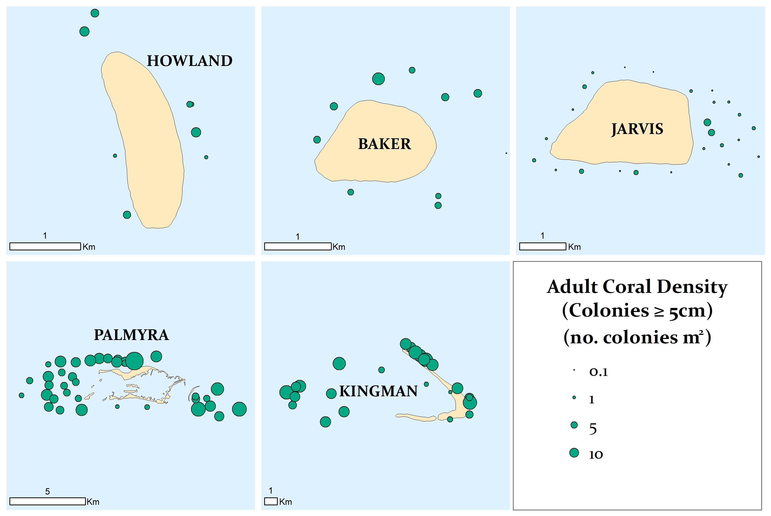

Figure 1. Mean density of all adult coral colonies (Scleractinia, ≥ 5 cm) at survey sites.

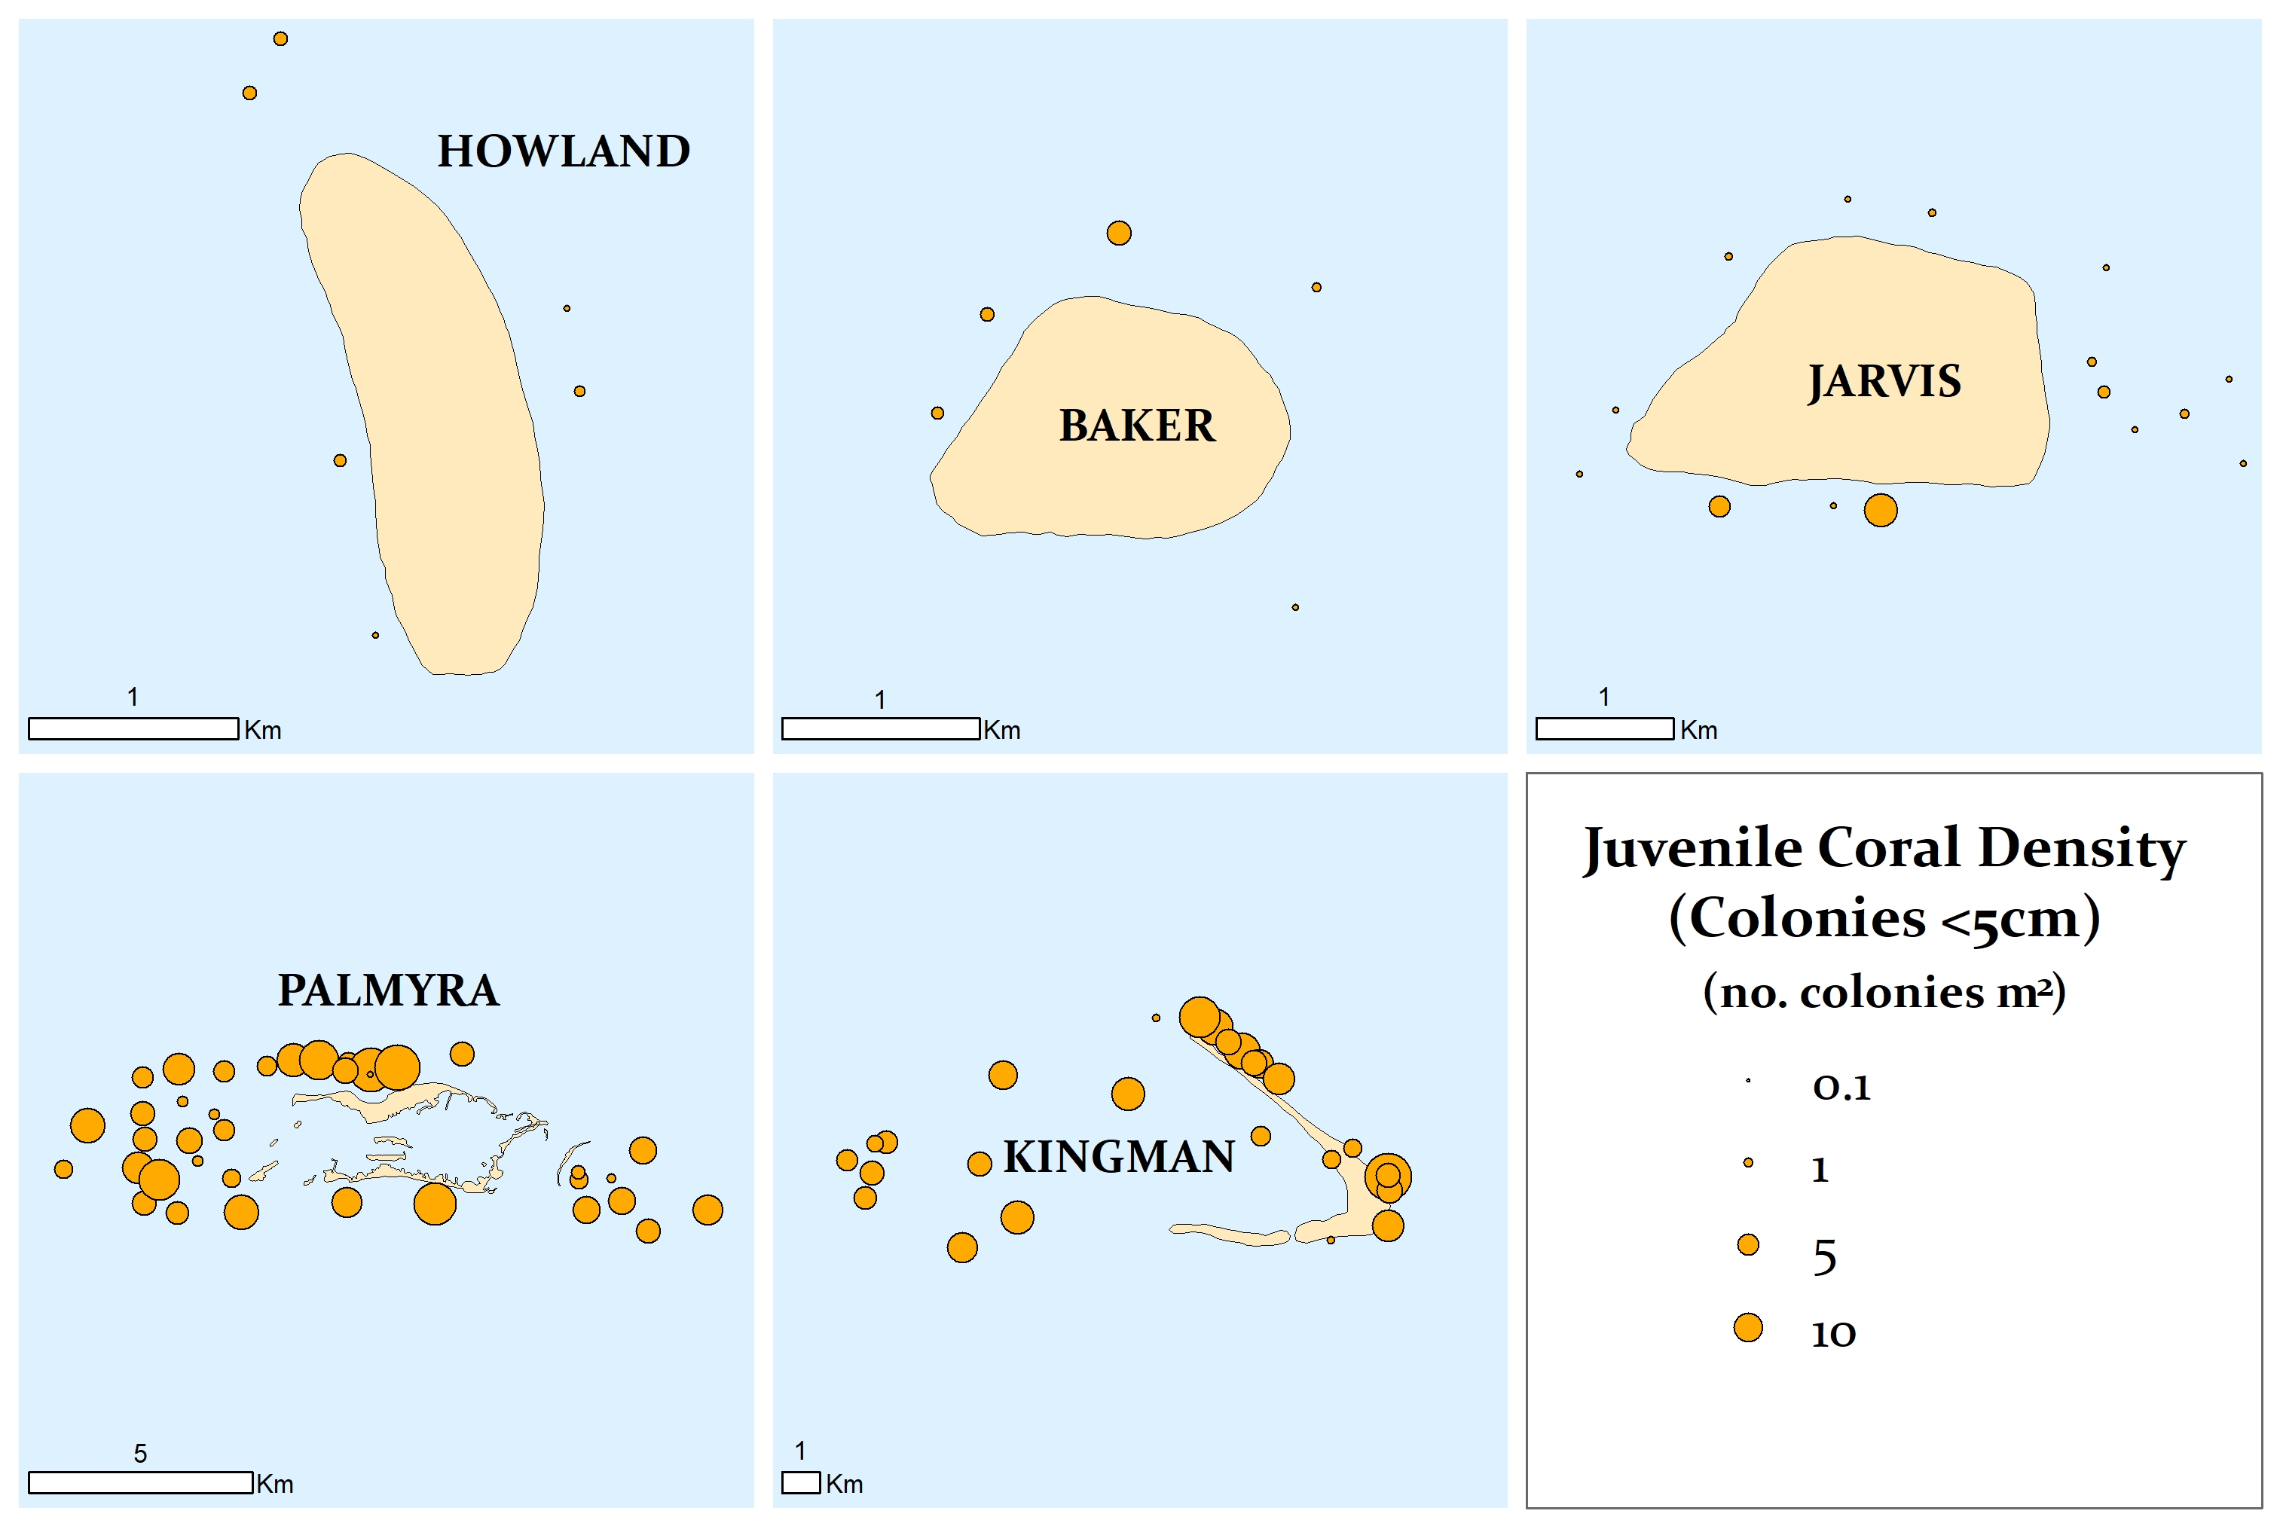

Figure 2. Mean density of all juvenile coral colonies (Scleractinia, < 5 cm) at survey sites.

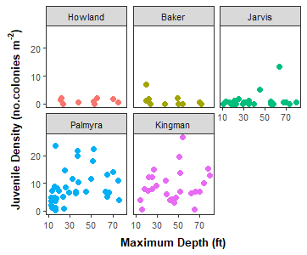

Figure 3. Density of juvenile coral colonies grouped by island across maximum site depth (ft).

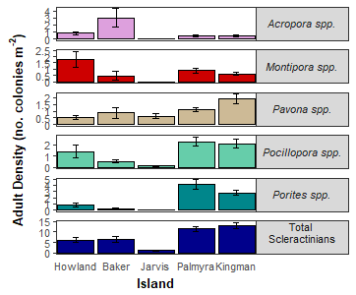

Figure 4. Mean island-wide density of adult colonies (± SE) for total scleractinians and the five most abundant genera: *Acropora*, *Montipora*, *Pavona, Pocillopora*, and *Porites*. Note: the scale of the y-axis is not consistent across taxa.

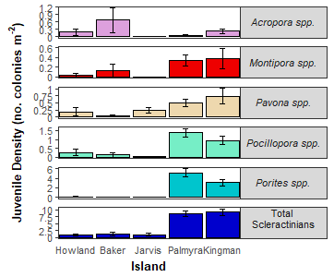

Figure 5. Mean island-wide density of juvenile colonies (± SE) for total scleractinians and the five most abundant genera: *Acropora*, *Montipora*, *Pavona, Pocillopora*, and *Porites*. Note: the scale of the y-axis is not consistent across taxa.

*Coral condition and threatened species*- The percent of adult coral colonies exhibiting signs of bleaching, disease, or crown-of-thorns sea star (COTS) predation lesions as well as the mean percent of each colony with partial mortality are shown in Table 2. Bleaching included any loss of pigmentation. Acute Disease was defined diseases resulting in tissue mortality. Chronic Disease refers to diseases that do not result in tissue loss. COTS was defined as recent coral mortality attributable to COTS predation. The Endangered Species Act (ESA) threatened species were not observed.

Table 2. Percent of adult coral colonies that exhibited bleaching (BLE), acute and chronic disease, crown-of-thorns sea star (COTS) predation lesions and partial mortality (including old and recent).

|  |  |  |  |  |  |
| --- | --- | --- | --- | --- | --- |
| Island | %BLE | %Acute  Disease | %Chronic  Disease | %COTS | %Mortality |
| Baker | 0.35 | 0.87 | 10.24 | 0.00 | 15.92 |
| Howland | 1.09 | 0.85 | 0.00 | 0.00 | 10.35 |
| Jarvis | 1.32 | 1.92 | 0.21 | 0.00 | 12.95 |
| Kingman | 7.58 | 0.67 | 0.20 | 1.40 | 17.67 |
| Palmyra | 8.80 | 0.72 | 0.04 | 1.44 | 14.44 |

## Preliminary observations

Jarvis's benthic communities were severely impacted by the recent 2015-2016 bleaching event with ~98% coral mortality. Based on preliminary observations in 2018, we recorded extremely low densities of both adult and juvenile corals, suggesting that there has been little to no recovery. There are, however, portions of the eastern shallow reefs that still have large living massive colonies. We also documented a dramatic increase in crustose coraline algae that covered much of the dead substrate and even overgrew living corals.

At Palmyra, we recorded moderate to high coral cover and high coral diversity. While there was evidence of mortality for *Acropora* and other sensitive taxa, it was highly variable across the atoll. Similar to previous years, coral juvenile density was high, suggesting that Palmyra still has high recovery potential. In general, corals showed low levels of disease or compromised signs of health. While COTS predation was low overall, several sites had high densities outside the transects.

Kingman surveys suggest that coral communities, notably *Acropora*, experienced mortality on the forereef and backreef zones. Corals fared better on portions of the western protected reef slope. We saw diverse and high densities of coral juveniles, suggesting that Kingman also has high recovery potential. Kingman’s corals were also very healthy, with the exception of COTS predation that was observed at most forereef sites. Similar to Palmyra, COTS densities were qualitatively abnormally high outside the transects.

## Survey design & methods

A single stage stratified random sampling design was employed to survey the PRIMNM. The stratification scheme incorporated all forereef, backreef, lagoon and protected reef slope hard bottom habitats, and sampled across three depth categories: shallow (0-6 m), mid (>6-18 m) and deep (>18-30 m). Allocation of sampling effort was proportional to total strata area. Sites (geographic coordinates) were randomly selected within each stratum.

Coral demography surveys at each site were conducted along one belt transect. Adult coral colonies (≥ 5 cm) were surveyed within 10 m2 and juvenile coral colonies (< 5 cm) were surveyed within 3 m2 on each transect. Colonies were identified to the lowest taxonomic level possible, measured (maximum diameter to the nearest cm), and morphology was noted. In addition, partial mortality and condition of each colony was assessed. Partial colony mortality was quantified as the percent of old and recent dead tissue, and attributed to cause of mortality when known. Conditions affecting each colony (i.e., disease and bleaching) were noted, along with the extent (percent of colony affected) and severity (ranging from moderate to acute). See <https://repository.library.noaa.gov/view/noaa/18267> for details on survey methodology.

The present summary focuses only on colony density and initial estimates of bleaching, disease, and COTS predation occurrence. The island-scale estimates presented here are generated from site-level means and are not weighted by reef area within depth strata; statistical analyses are forthcoming.

## About the monitoring program

Pacific RAMP forms a key part of the National Coral Reef Monitoring Program of NOAA’s Coral Reef Conservation Program (CRCP), providing integrated, consistent, and comparable data across US Pacific islands and atolls. CRCP monitoring efforts have these aims:

* Document the status of reef species of ecological and economic importance
* Track and assess the status and trends of US coral reef ecosystems in response to environmental stressors and human activities
* Evaluate the effectiveness of specific management strategies and identify actions for future and adaptive responses

In addition to the coral population and benthic community surveys outlined here, Pacific RAMP efforts include interdisciplinary monitoring of oceanographic conditions, fish population and assemblages, invertebrate diversity and abundance, coral reef habitat assessments and mapping, and studies of the effects of climate change and ocean acidification.

## For more information

Coral Reef Conservation Program:  
<http://coralreef.noaa.gov>  
NMFS Pacific Islands Fisheries Science Center:  
<http://www.pifsc.noaa.gov>  
Related publications:  
<http://www.pifsc.noaa.gov/pubs/credpub.php>  
Additional information:  
<http://www.pifsc.noaa.gov/cred/benthic_monitoring.php>  
Benthic survey data requests:  
[courtney.s.couch@noaa.gov](mailto:courtney.s.couch@noaa.gov)